Point in Space
# Source: AI Source: Provided by: [Data Path: Persons Table -> ID Column: 1, Name_En Column: Motasem Essam] -> From: [ChatGPT] on [7/25/2026]
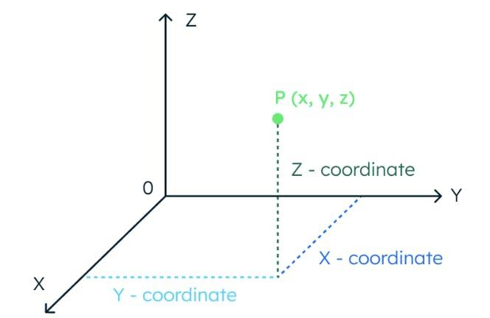
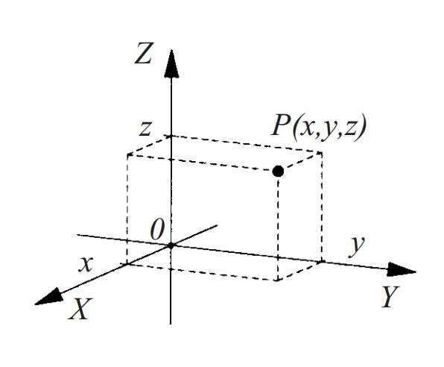
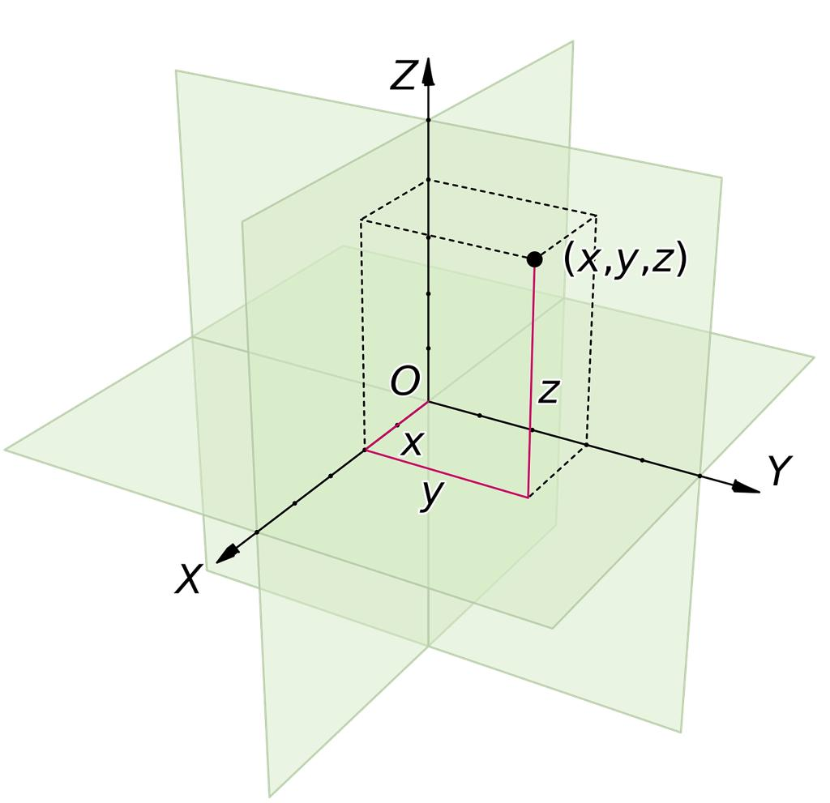

Definition
# Source: AI Source: Provided by: [Data Path: Persons Table -> ID Column: 1, Name_En Column: Motasem Essam] -> From: [ChatGPT] on [7/25/2026]
A point in space is a precise location in three-dimensional space, specified independently of any particular line, plane, or solid. In three-dimensional Cartesian geometry, a point is represented by three coordinates $\left(x,y,z\right)$, which determine its position relative to the coordinate axes and origin.
A point in space has no length, width, or height. It represents a location rather than a physical object with dimensions.

Simple Definition
# Source: AI Source: Provided by: [Data Path: Persons Table -> ID Column: 1, Name_En Column: Motasem Essam] -> From: [ChatGPT] on [7/25/2026]
A point in space is a single location in three-dimensional space, represented by three coordinates.
For example,
$$P=\left(3,4,5\right)$$
means that point $P$ has coordinates $x=3$, $y=4$, and $z=5$.

Key Characteristics
# Source: AI Source: Provided by: [Data Path: Persons Table -> ID Column: 1, Name_En Column: Motasem Essam] -> From: [ChatGPT] on [7/25/2026]
- Zero-dimensional: A point has no length, area, or volume.
- Three coordinates: In Cartesian space, its position is represented by $\left(x,y,z\right)$.
- Unique location: A given coordinate triple identifies one point in a fixed coordinate system.
- No physical size: A point is an abstract geometric concept, even when drawn as a dot.
- Independent location: A point can exist anywhere in space, whether or not it lies on a particular solid.
- Reference-dependent coordinates: The coordinates depend on the chosen origin, axes, and units.

Representing a Point in Space
# Source: AI Source: Provided by: [Data Path: Persons Table -> ID Column: 1, Name_En Column: Motasem Essam] -> From: [ChatGPT] on [7/25/2026]
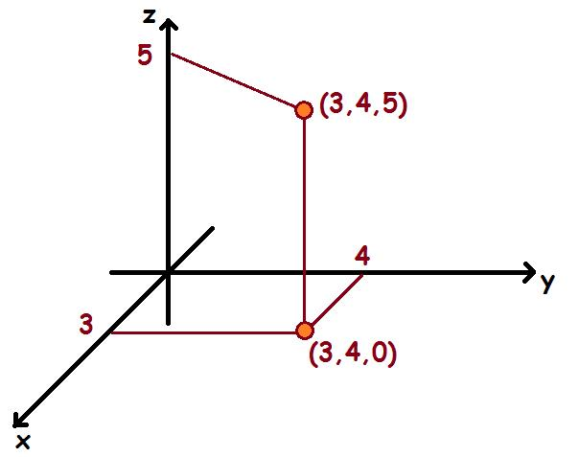
A point in three-dimensional Cartesian space is written as
$$\boxed{P=\left(x,y,z\right)}$$
The coordinates represent its position along three mutually perpendicular axes:
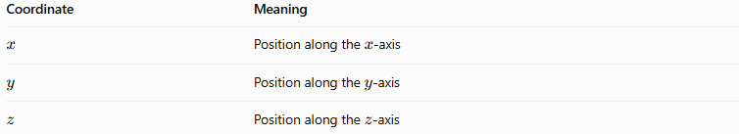
Coordinate | Meaning
$$x$$ | Position along the $x$-axis
$$y$$ | Position along the $y$-axis
$$z$$ | Position along the $z$-axis
For example, for $P=\left(3,4,5\right)$, the point is located 3 units along the positive $x$-direction, 4 units along the positive $y$-direction, and 5 units along the positive $z$-direction from the origin.

Special Points in Space

1. Origin
# Source: AI Source: Provided by: [Data Path: Persons Table -> ID Column: 1, Name_En Column: Motasem Essam] -> From: [ChatGPT] on [7/25/2026]
The point where all three coordinate axes intersect.
$$O=\left(0,0,0\right)$$
It is the reference point for measuring coordinates.
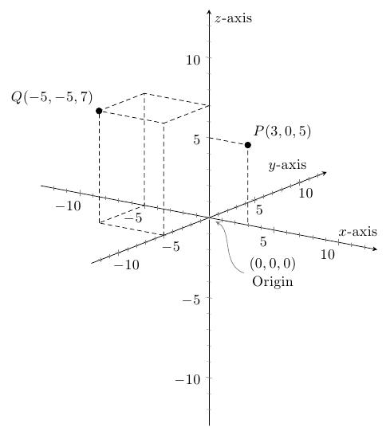

2. Point on a Coordinate Axis
# Source: AI Source: Provided by: [Data Path: Persons Table -> ID Column: 1, Name_En Column: Motasem Essam] -> From: [ChatGPT] on [7/25/2026]
A point on one coordinate axis has the other two coordinates equal to zero.
Examples:
- $P=\left(a,0,0\right)$: on the $x$-axis.
- $P=\left(0,b,0\right)$: on the $y$-axis.
- $P=\left(0,0,c\right)$: on the $z$-axis.
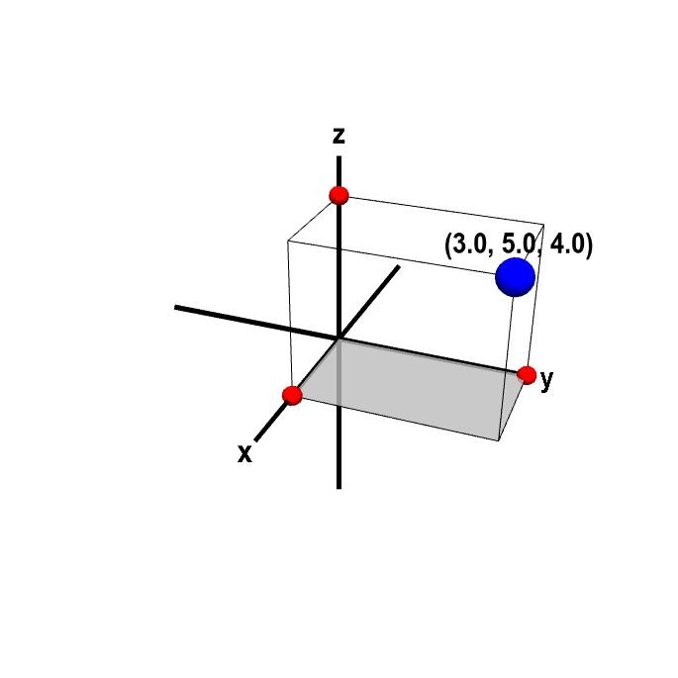

3. Point on a Coordinate Plane
# Source: AI Source: Provided by: [Data Path: Persons Table -> ID Column: 1, Name_En Column: Motasem Essam] -> From: [ChatGPT] on [7/25/2026]
A point lies on a coordinate plane when the coordinate perpendicular to that plane is zero.
- $z=0$: on the $xy$-plane.
- $y=0$: on the $xz$-plane.
- $x=0$: on the $yz$-plane.

4. Point in the Interior of a Solid
# Source: AI Source: Provided by: [Data Path: Persons Table -> ID Column: 1, Name_En Column: Motasem Essam] -> From: [ChatGPT] on [7/25/2026]
A point located strictly inside a solid, not on its boundary.
Example: A point inside a cube without touching any face.
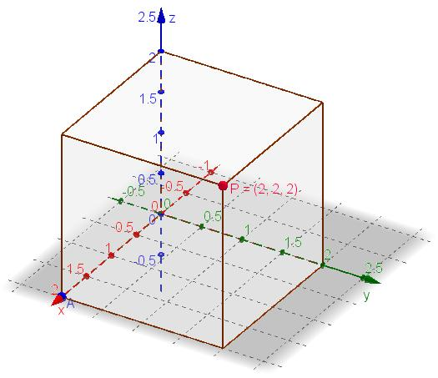

5. Point on the Boundary of a Solid
# Source: AI Source: Provided by: [Data Path: Persons Table -> ID Column: 1, Name_En Column: Motasem Essam] -> From: [ChatGPT] on [7/25/2026]
A point belonging to the outer boundary of a solid.
Example: A point on a cube's face, edge, or vertex.
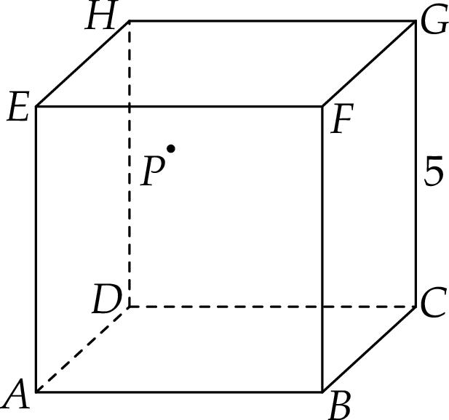

Fundamental Properties and Formulas

1. Distance from the Origin
# Source: AI Source: Provided by: [Data Path: Persons Table -> ID Column: 1, Name_En Column: Motasem Essam] -> From: [ChatGPT] on [7/25/2026]
For a point $P=\left(x,y,z\right)$, its distance from the origin $O=\left(0,0,0\right)$ is
$$\boxed{OP=\sqrt{x^{2}+y^{2}+z^{2}}}$$
Example: If $P=\left(3,4,5\right)$,
$$OP=\sqrt{3^{2}+4^{2}+5^{2}}=\sqrt{50}=5\sqrt{2}$$

2. Distance Between Two Points
# Source: AI Source: Provided by: [Data Path: Persons Table -> ID Column: 1, Name_En Column: Motasem Essam] -> From: [ChatGPT] on [7/25/2026]
For two points $P_{1}=\left(x_{1},y_{1},z_{1}\right)$ and $P_{2}=\left(x_{2},y_{2},z_{2}\right)$, their distance is
$$\boxed{d=\sqrt{{\left(x_{2}-x_{1}\right)}^{2}+{\left(y_{2}-y_{1}\right)}^{2}+{\left(z_{2}-z_{1}\right)}^{2}}}$$
This formula measures the straight-line distance between any two points in space.

3. Position Relative to a Solid
# Source: AI Source: Provided by: [Data Path: Persons Table -> ID Column: 1, Name_En Column: Motasem Essam] -> From: [ChatGPT] on [7/25/2026]
A point's coordinates can be used to determine whether it is inside, on the boundary of, or outside a specified solid.
For a closed sphere centered at the origin with radius $r$, let
$$s=x^{2}+y^{2}+z^{2}$$
Then:
- $s<r^{2}$: the point is inside the sphere.
- $s=r^{2}$: the point is on the spherical boundary.
- $s>r^{2}$: the point is outside the sphere.

Point in Space vs. Point on a Line vs. Point on a Plane
# Source: AI Source: Provided by: [Data Path: Persons Table -> ID Column: 1, Name_En Column: Motasem Essam] -> From: [ChatGPT] on [7/25/2026]
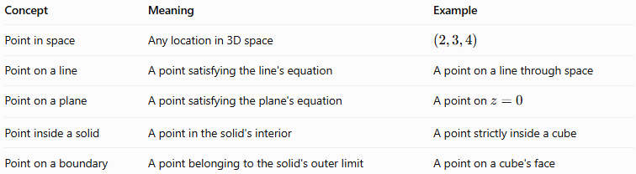
Concept | Meaning | Example
Point in space | Any location in 3D space | $$\left(2,3,4\right)$$
Point on a line | A point satisfying the line's equation | A point on a line through space
Point on a plane | A point satisfying the plane's equation | A point on $z=0$
Point inside a solid | A point in the solid's interior | A point strictly inside a cube
Point on a boundary | A point belonging to the solid's outer limit | A point on a cube's face
A point in space is the general concept. The other categories describe the point's relationship to a particular geometric object.

Applications
# Source: AI Source: Provided by: [Data Path: Persons Table -> ID Column: 1, Name_En Column: Motasem Essam] -> From: [ChatGPT] on [7/25/2026]
- Coordinate geometry: Locating and comparing points in three dimensions.
- Architecture: Representing corners and positions in building models.
- Engineering: Specifying the location of components in 3D designs.
- Computer graphics: Positioning objects, cameras, and vertices.
- Physics: Describing the position of particles or objects in space.
- Navigation and robotics: Determining spatial positions and distances.

Key Points
# Source: AI Source: Provided by: [Data Path: Persons Table -> ID Column: 1, Name_En Column: Motasem Essam] -> From: [ChatGPT] on [7/25/2026]
- A point in space represents a single location in three dimensions.
- Its Cartesian coordinates are written as $\left(x,y,z\right)$.
- The origin is $\left(0,0,0\right)$.
- A point on a coordinate axis has two zero coordinates.
- A point on a coordinate plane has one zero coordinate.
- The distance between points is calculated using the three-dimensional distance formula.
- A point may be classified according to its relationship with a line, plane, or solid.

Conclusion
# Source: AI Source: Provided by: [Data Path: Persons Table -> ID Column: 1, Name_En Column: Motasem Essam] -> From: [ChatGPT] on [7/25/2026]
A point in space is the fundamental zero-dimensional element used to describe locations in three-dimensional geometry. Its three coordinates uniquely specify its position in a chosen Cartesian coordinate system. Points provide the foundation for defining lines, planes, vertices, and solids, as well as calculating spatial distances and analyzing geometric relationships.

